**Engineering exploration Project E11  
Smart Irrigation System**

**Introduction**

* Here We are making an**Automatic/Smart Irrigation System** with an **Arduino Uno** which will irrigate your plants automatically and keep them healthy even when you are out of the town for weeks or months. In this project, a **Moisture sensor**will be used to maintain the optimum level of moisture for your plants. This system can be implemented, both for yourgarden or for your Indoor plants thus taking care of your leafy pets when you are away.

**Working of the Automatic Irrigation System**

* The logic of this system is very simple. In this system, the moisture sensor senses the moisture level of the soil and when the sensor senses a low moisture level it automatically switches the water pump with the help of a microcontroller and irrigates the plant. After supplying sufficient water, the soil gets retains the moisture hence automatically stopping the pump.

Components

* **Soil Moisture Sensor**

* The working of the soil moisture sensor is very easy to understand. It has 2 probes with exposed contacts that act like a **variable resistor** whose **resistance varies**according to the water content in the soil.
* The sensor produces an **analog voltage output** according to the **resistance**.
* The module has an **LM393 High Precision Comparator** which converts the analog signal to a Digital Output which is fed to the microcontroller.
* **Water Pump**

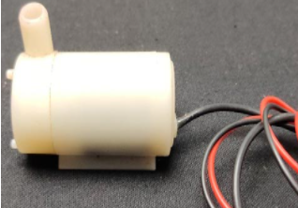

* We need a small pump to irrigate the plant, but in the case of a garden, we need to drive a larger pump that can provide a higher volume of water depending on the size of your garden which can’t be directly powered by an Arduino, To operate a larger pump, a driver is necessary to provide enough current for the pump. You can also use an AC-powered pump and use a suitable relay
* **2-Channel 5V Relay Module**

* 2-Channel 5V Relay Module is **a relay interface board**, it can be controlled directly by a wide range of microcontrollers such as Arduino, AVR, PIC, ARM and so on. It uses a low-level triggered control signal (3.3-5VDC) to control the relay. Triggering the relay operates the normally open or normally closed contacts.
* Good for safe control of higher amperage circuits. In power systems, the lower current can control the higher one.
* 2-channel high voltage system output, meeting the needs of dual channel control.
* **MQ9 Gas Sensor**

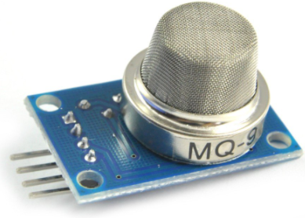

* The Grove - Gas Sensor (MQ9) module is **useful for gas leakage detection (in home and industry)**. It is suitable for detecting LPG, CO, CH4. Due to its high sensitivity and fast response time, measurements can be taken as soon as possible. The sensitivity of the sensor can be adjusted by using the potentiometer.
* **DHT Sensor**

* The DHT11 is a basic, ultra-low-cost digital temperature and humidity sensor. It uses a capacitive humidity sensor and a thermistor to measure the surrounding air and spits out a digital signal on the data pin (no analog input pins needed). It’s simple to use but requires careful timing to grab data.

### ****Components Required for the Automatic Irrigation System****

The project requires very few components, and the connection is also very simple. The components are listed below:

* Arduino * 1
* moisture sensor * 1
* 5v relay module * 1
* 6v Mini water pump with small pipe * 1
* Connecting wires
* 5v battery * 1

### ****Assembling the Automatic Irrigation System****

* Let's start with connecting the relay to the Arduino board. Connect the VCC of the relay module to the 5v pin of the Arduino and connect the ground of the relay to the ground of Arduino. Now connect the relay signal pin to any digital pin of Arduino except pin 13. Here I have connected it to pin 3 as shown in the image below.

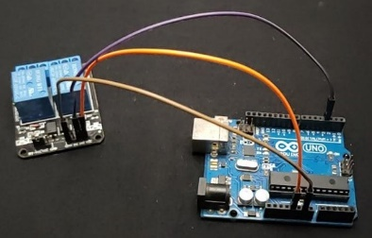

* The next step is to connect the soil moisture sensor with the Arduino. Connect the VCC and GND of the sensor to the 5volt and ground pin of the Arduino. The analogue output of the sensor connects to any analogue pin of the Arduino, here I’ve connected it to pin A0 (according to our program).

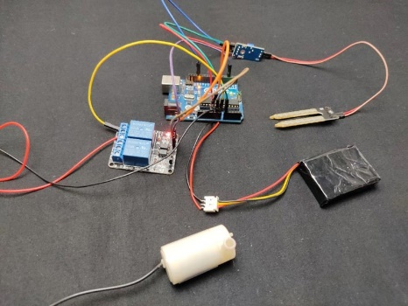

* Finally, connect the pump to the relay module. A relay module has 3 connection points which are common, normally closed, and normally open. We have to connect the pump positive to common and connect the normally open pin to the positive of the battery. You must select the battery as per your pump. The next step is to connect the ground of the pump to the ground of the Arduino and finally, connect the small hose to the water pump.
* Now connect the battery to the circuit and if the pump starts working then your circuit is okay. Now let's upload code to Arduino.